SQL ASSIGNMENT 1

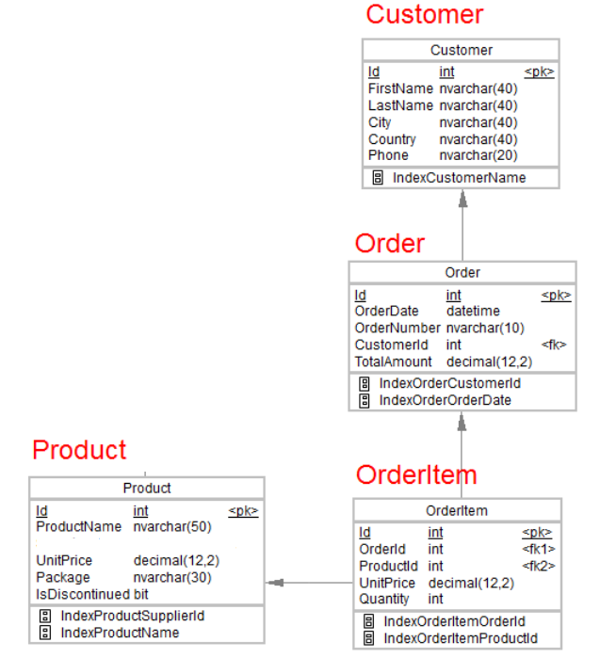

**1. Design the above database with following table by applying Primary key and Foreign key**

Created Database using the graphical method

1. Product Table (tblProduct)

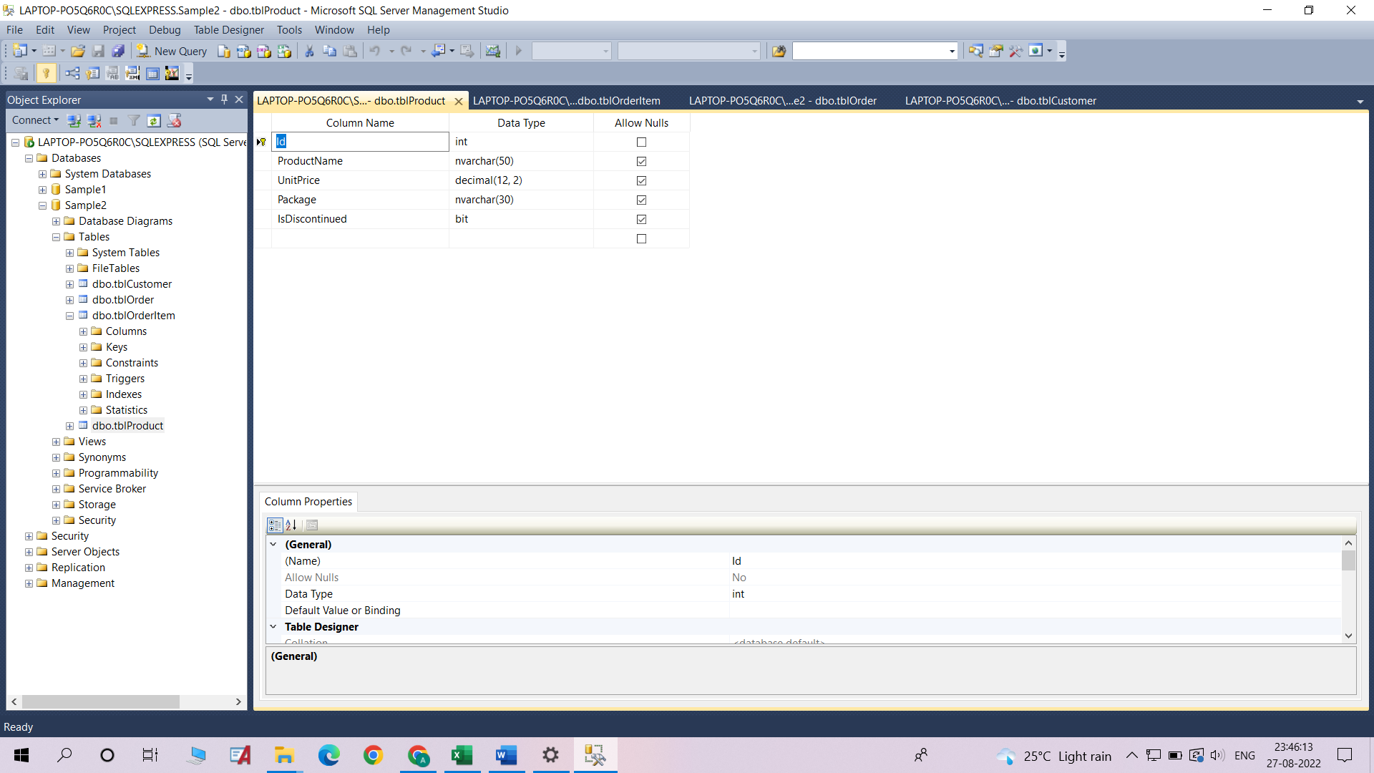

1. OrderItem Table (tblOrderItem)

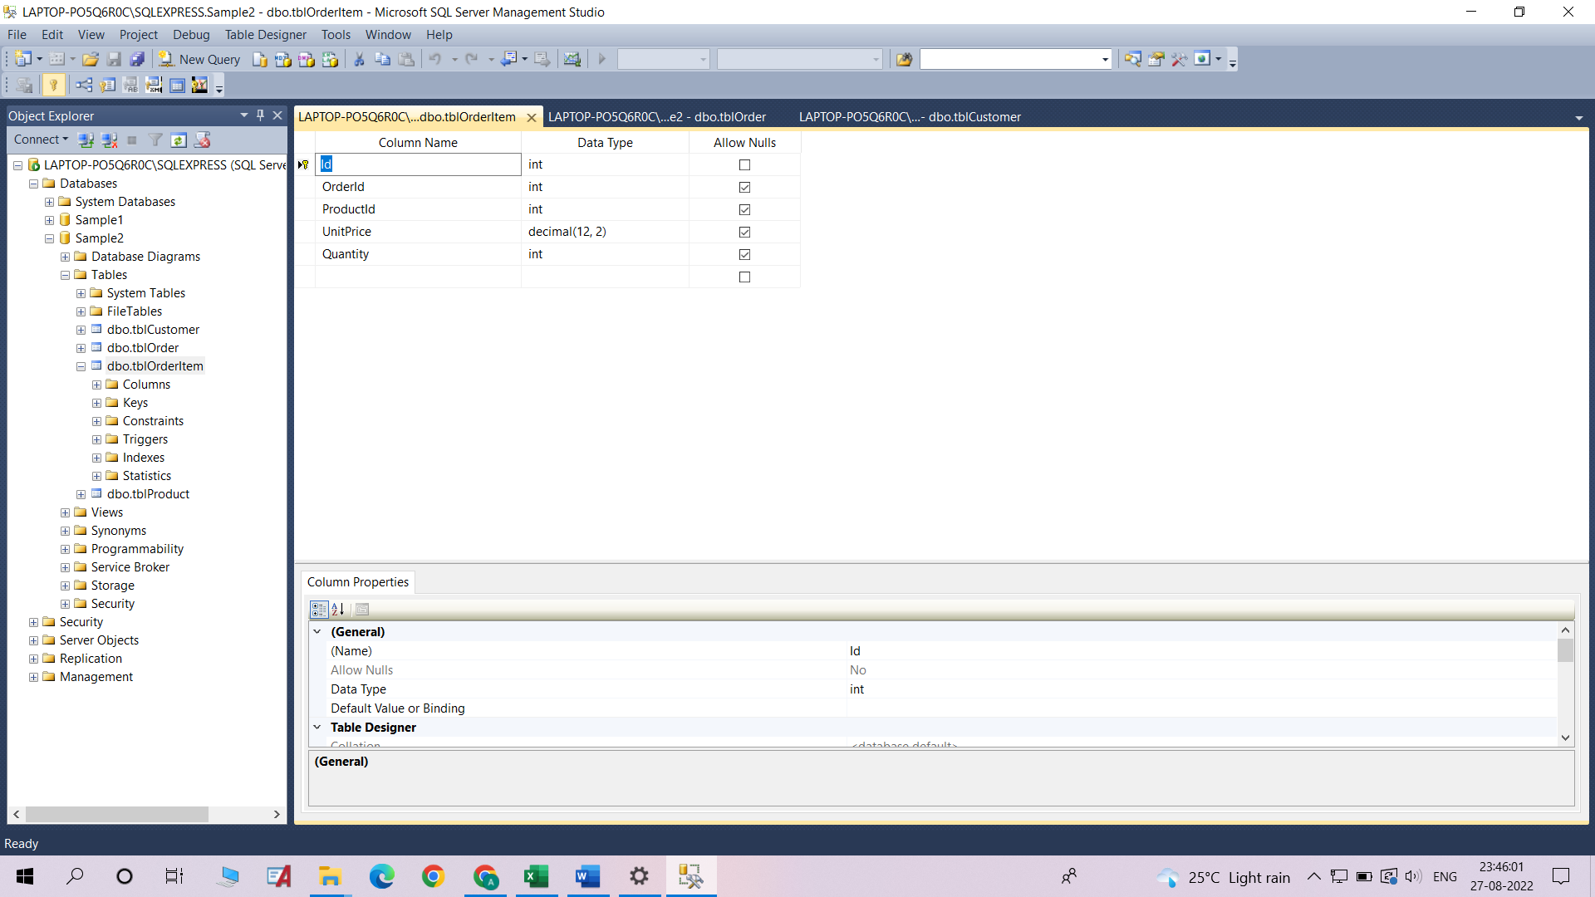

1. Order Table (tblOrder)

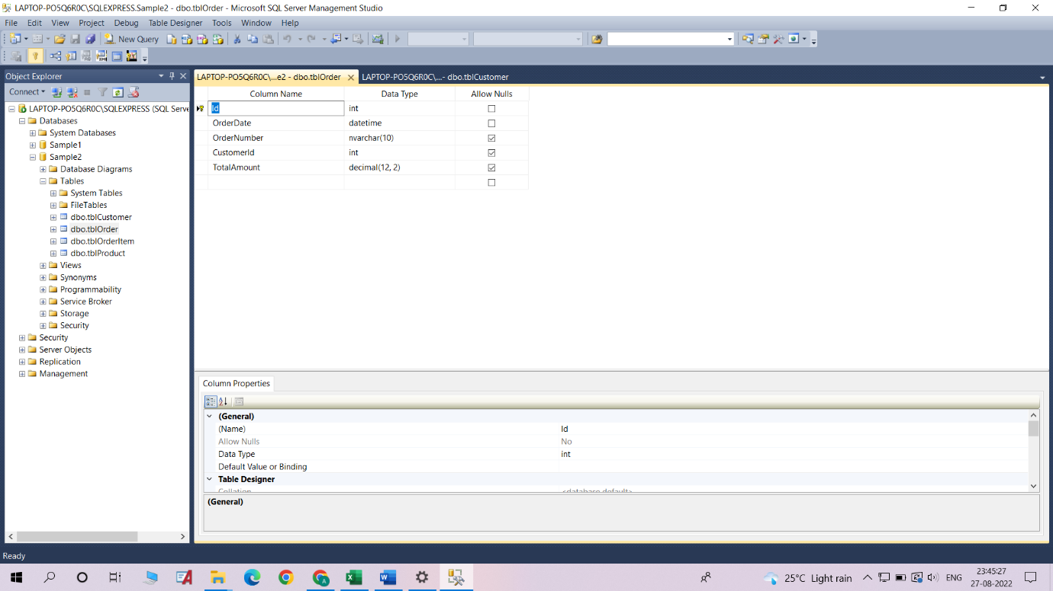

1. Customer Table (tblCustomer)

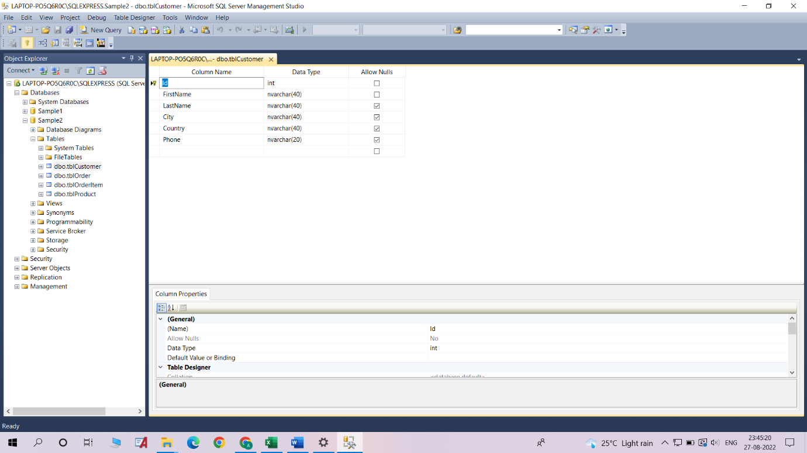

**2.Insert Records in all tables**

Inserted records for all of the tables using the graphical method

1. Product Table (tblProduct)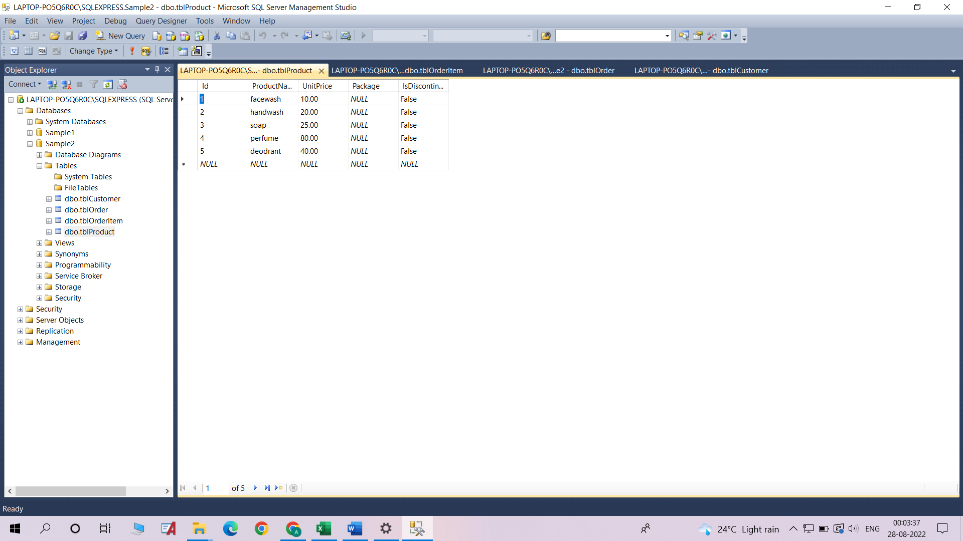
2. OrderItem Table (tblOrderItem)

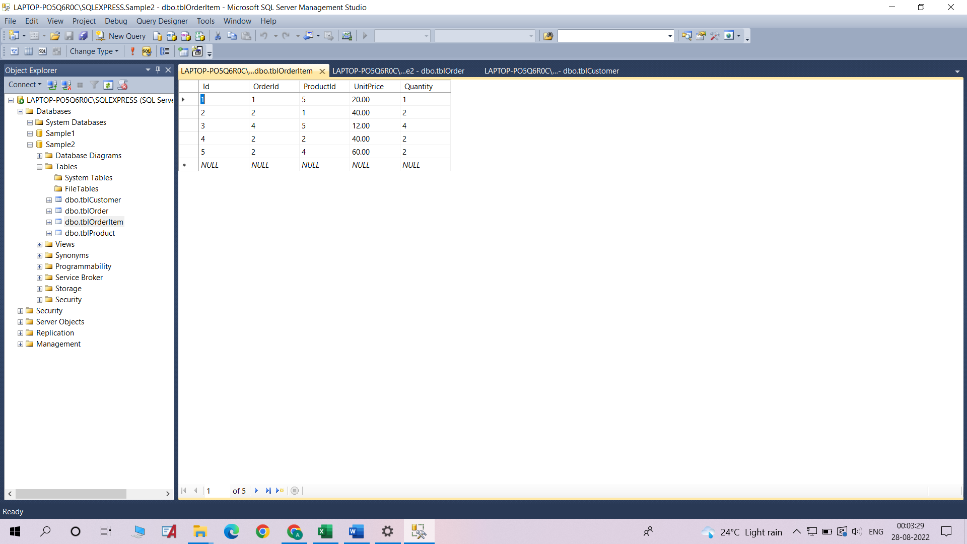

1. Order Table (tblOrder)

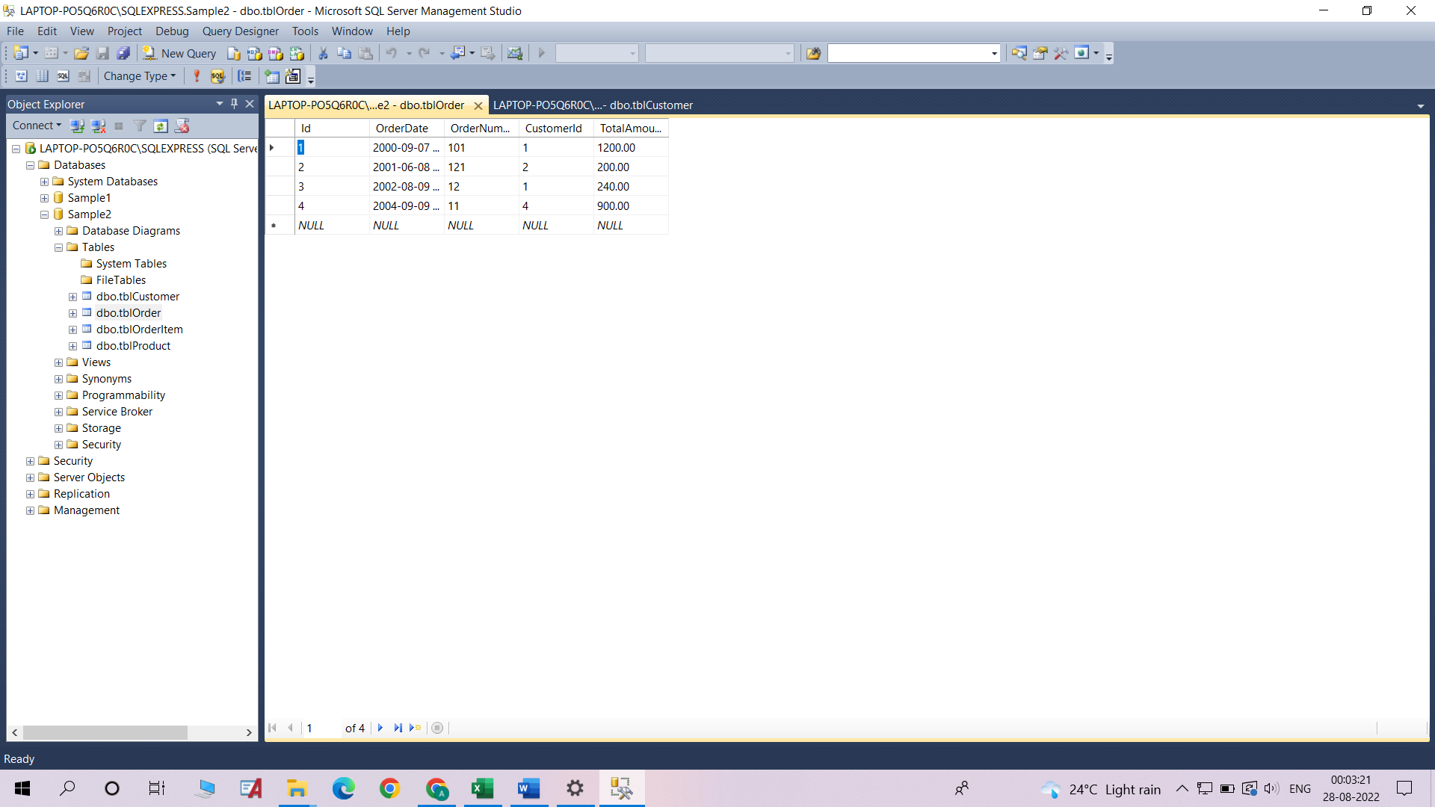

1. Customer Table (tblCustomer)

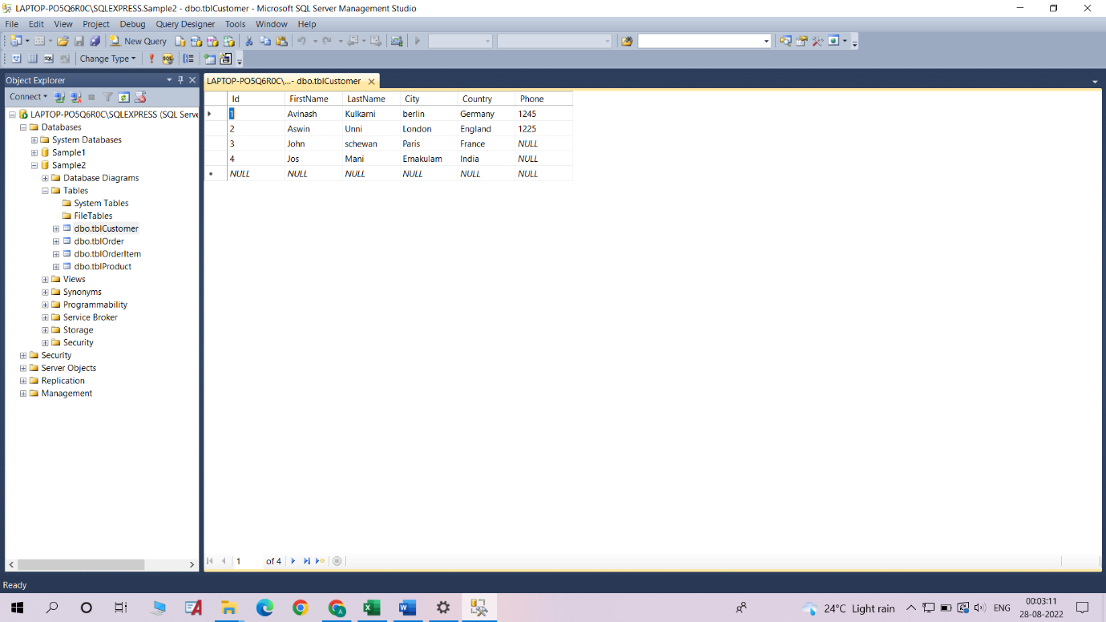

**3.In Customer table FirstName Attribute should not accept null value**

Added this Constraint using the graphical method

**4.In Order table OrderDate should not accept null value**

Added this Constraint using the graphical method

**5.Display all customer details**

In SQL Assign 1 file

**6.Write a query to display Country whose name starts with A or I**

In SQL Assign 1 file

**7.Write a query to display whose name of customer whose third character is I**

In SQL Assign 1 file